While a slight difference in neglect incidence between the sexes was established by Hammerbeck et al. (2019), studies on sex differences in neglect severity as measured by commonly used diagnostic tests have been few and inconclusive so far. For example, Kleinman et al. (2008) analysed the demographic data of 312 right-hemispheric stroke patients (49.7% female), as well as their performance across various diagnostic tests. They found no significant differences between the sexes, except for age at stroke onset, with women being about 4 years older than men. Interestingly though, Varnava & Halligan (2007) found that the performance in some diagnostic tests, such as the line bisection task, is influenced by an interaction of sex and age: With increasing age, performance decreases in women, while no such trend exists in men.

#####################################################################################

Considering that some researchers have advocated to consider neglect a disconnection syndrome, rather than a syndrome caused by focal cortical lesions (Bartolomeo et al., 2007; Doricchi et al., 2008; Thiebaut de Schotten et al., 2008), and that men and women differ in their underlying structural brain connectivity (Ingalhalikar et al., 2013), it seems possible that differences between the sexes may (only) manifest in the stroke-induced disconnections.

#####################################################################################

However, to the best of our knowledge, potential sex differences in the neural underpinnings of neglect have not been researched so far. We believe that it is crucial to investigate which role sex plays as a factor in this syndrome, as understanding how the symptoms manifest on a neurological level may aid in the clinical treatment of people suffering from neglect.

To this end, we want to investigate sex differences in visuospatial neglect-related lesion patterns and/or disconnections.

Firstly, we want to investigate if we can find any sex differences in the clinical and demographic data of our patient sample, which would be in in line with the previous research on sex differences in the pathophysiology in stroke (cf., Bonkhoff et al., 2021; Hammerbeck et al., 2019).

Secondly, we want to test if classical voxel-based lesion-behaviour can reveal any differences in the relation between focal lesions and neglect severity between men and women.

Thirdly, we want to investigate if the sex differences in hemispheric asymmetry and brain connectivity (as described e.g., by Ingalhalikar et al., 2013) also result in differences in WM disconnectivity after stroke. To this end, we will use Griffis et al.’s (2021) indirect method of assessing different disconnectivity measures based on lesion data, rather than assessing them directly using DTI.

[hypotheses]

#####################################################################################

*[While studies utilising animal models provided vast evidence that anatomical hemispheric asymmetries and FCAs are related (for reviews see Corballis & Häberling, 2017; Ocklenburg & Güntürkün, 2012), there is much less research on the direct relation of structural anatomical WM asymmetries and functional lateralization in humans. Schulte et al. (2010) conducted one of the few studies that directly studied this relationship: They used a combination of DTI and fMRI measurements and established that WM degradation in the corpus callosum due to alcoholism attenuates the normal pattern of FCAs, which impairs visuomotor integration. Besides this experimental study, meta-analyses such as by Hausmann (2016) and Hirnstein et al. (2019) have revealed that the results of studies investigating FCAs (e.g., Bless et al., 2015; Hirnstein et al., 2013) largely align with the results of studies demonstrating anatomical hemispheric asymmetries in language lateralisation (e.g., Guadelupe et al., 2015; Li et al., 2014).]

#####################################################################################

**SSPLs:**

The previously described analysis allows assessing the immediate impact a focal lesion has on direct connections between two given brain regions. However, it fails to account for indirect connections that are achieved via a number of direct connections between intermediary regions. For that reason, we also investigated the increase in ROI-to-ROI shortest structural path lengths (SSPLs). The SSPL score of a parcel pair expresses how many direct connections must be traversed to establish a structural pathway between them, with parcel pairs that share a direct connection having a score of 1. Focal lesions may therefore not only cause direct disconnections, but also indirect disconnections and an associated increase in SSPLs if now a “detour” via other intermediary parcels must be used to maintain the connection (Griffis et al., 2020 & 2021). (is this even needed?)

#####################################################################################

Figure 3a depicts the voxels that were damaged more frequently in one sex than the other in Subtraction Plots. The voxels that most notably were damaged more often in women were mostly clustered in the thalamus, as well as the putamen and ventral caudate of the BG. The voxels that were damaged more frequently in men were spread out more across the brain. Notable clusters include the inferior frontal gyrus (IFG), orbital gyrus (OrG), superior temporal gyrus (STG) and posterior STG and medioventral occipital cortex (MVOcC).

When contrasting only female and male patients diagnosed with visuospatial neglect (see Figure 3b), the patterns look very similar to the ones found for the whole patient sample. The most prominent cluster of voxels damaged more frequently in women than in men is located again in the thalamus, but another notable cluster emerged surrounding the middle frontal gyrus (MFG). Male neglect patients had more damaged voxels in the dorsal caudate region of the BG, the inferior parietal lobule (IPL) and STG.

Female > Male:

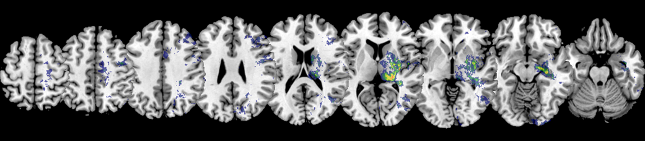

Male > Female:

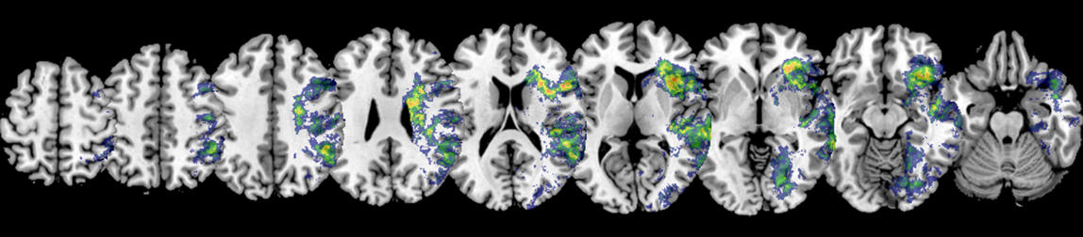

Neglect Female > Neglect Male:

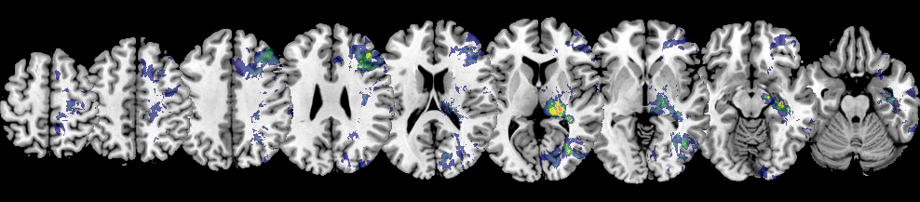

Neglect Male > Neglect Female:

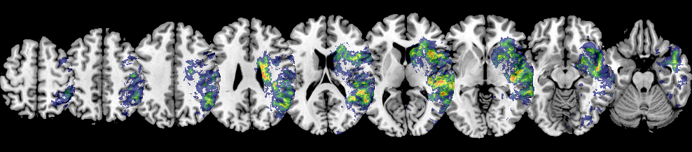

**Figure 3:** Subtraction Plots   
Subtraction plots of the normalised acute lesions for the (A) female and male patient sample and (B) female and male neglect patient sample, respectively. Subtraction maps were overlaid on an axial view of the ch2bet-template in MRIcron (Rorden & Brett, 2000). The voxels’ colours indicate the percentage of relative frequency difference between the patient groups. Only voxels damaged in at least 5 patients are depicted and were used for subsequent analyses. The number given above each slice refers to the z-coordinate in MNI space.

#####################################################################################

Female:

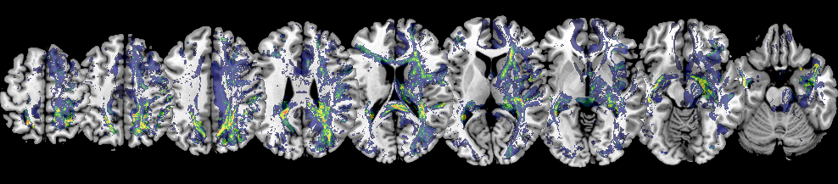

Male:

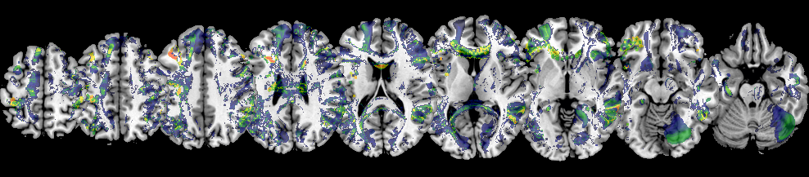

**Figure 6:** Subtraction Plots of Whole-Brain Disconnectivity

Subtraction plots of the whole-brain disconnection maps for the female and male patient sample, respectively. Subtraction maps were overlaid on the ch2bet-template in MRIcron (Rorden & Brett, 2000). The number given above each slice refers to the z-coordinate in MNI space. The voxels’ colours indicate the percentage of relative frequency difference between the patient groups.